Sun | Mon | Tue | Wed | Thu | Fri | Sat
 |  | 1  St. Vincent  de Paul  9:30 – 11:30 am | 2  CCD CLASSES  6pm-7:30pm | 3  St. Vincent de Paul  9:30 – 11:30am  Combined Meeting with Holy Family Pastoral Council and Building & Finance Council in Room 2 at 7p.m. | 4  HOLY HOUR @ 7pm in the Church | 5  Men’s Ministry Rm #2 @ 7:30 am  CCD 1ST Communion Practice at 1pm  Rancher Plate  11:00AM- 2 PM  Reconciliation in Church  @ 5-5:45pm
6 Breakfast- Prayer Group  CCD - 8:30am-11:45am  Coronation of Blessed Virgin Mother before the 9:30 a.m.  TEEN ACTS MEETING AT 1:30 PM TO 3:30 PM | 7  Youth Ministry  6:30 pm Classroom #3 | 8  St. Vincent  de Paul  9:30 – 11:30 am  Faith Sharing  7pm in  Classroom# 1 | 9  CCD CLASSES  6pm-7:30pm  Festival Fundraising Committee Meeting 6pm-in Parish Hall | 10 St. Vincent  de Paul  9:30 – 11:30am | 11  Mother’s  Day Dinner Hosted by Ministry of the Holy Family  7pm Parish Hall | 12 Men’s Ministry Rm #2 7:30a.m.  Women’s Fellowship Rm#1 @ 7:30am  CCD FIRST HOLY COMMUNION  AT 1 P.M.  HALL RENTAL
13 No Breakfast  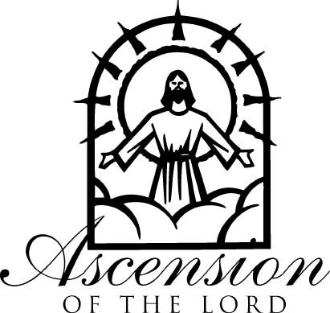 | 14  TEEN ACTS MEETING AT 1:30 PM TO 3:30 PM | 15  St. Vincent de Paul  9:30 – 11:30 am | 16  Last Wednesday CCD CLASSES  6pm-7:30pm | 17  St. Vincent de Paul  9:30 – 11:30am | 18 | 19  Men’s Ministry Rm #2 7:30am  ACTS DAY RETREAT  7:30-4pm  Reconciliation in  Church at 5-5:45 pm  Teen ACTS day retreat  8:30am-3:30pm
20 Breakfast-St. Vincent  Last Day-CCD CLASSES  8:30am-11:45am  Actividades Marianas  Meeting at 9:30am in the Parish Hall  TEEN ACTS MEETING AT 1:30 PM TO 3:30 PM | 21  Youth Ministry  6:30 pm Classroom #3 | 22  St. Vincent de Paul  9:30 – 11:30 am  Women of the Well  At 6:30pm-Classroom# 1 | 23 | 24  St. Vincent de Paul  9:30am-11:30am | 25  Men’s Ministry Rm #2 7:30am  Women’s Fellowship Rm#1 @ 7:30am | 26  Men’s Ministry Rm #2 7:30am  Women’s Fellowship  Rm#1 @ 7:30am  Reconciliation in Church at 5-5:45pm  HALL RENTAL
27 No Breakfast  ACTS CORE & COMMUNITY MEETING AT 1:30P ROOM 1 | 28 | 29 | 30 | 31

