Crowning Of Our Blessed Mother
Sunday, May 6, 2018
10:00 a.m. Mass
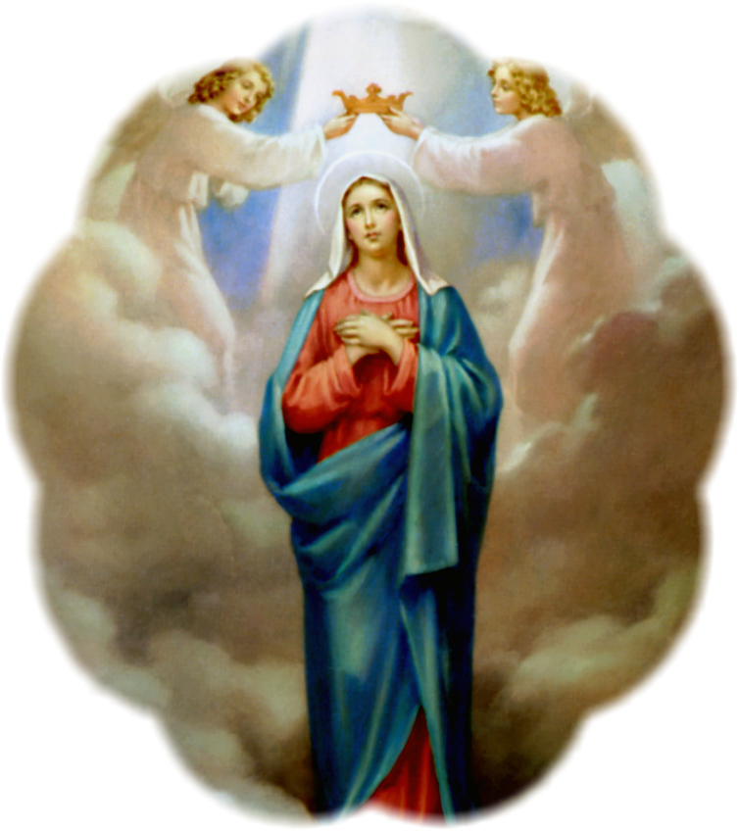
Everyone is invited!
Please come to honor Our Blessed Mother.

9:30 a.m. – Activities begin outside of the Rose Garden.
Flowers will be passed out by the Marianas
Two CCD students will crown our Blessed Mother

9:45 a.m. – Everyone inside the Church

9:50 a.m. – Crowning of Our Blessed Mother

10:00 a.m. – Holy Mass celebrated by Father Emmet

**After Mass the children will be served refreshments

